***Name: Kishan Dabhi***

Tacsk 1: Promoted

********** HTML CODE ********************

<!DOCTYPE html>

<html lang="en">

<head>

<meta charset="UTF-8">

<meta name="viewport" content="width=device-width, initial-scale=1.0">

<title>Task 1</title>

<link rel="stylesheet" href="style1.css">

</head>

<body>

<div class="food-card">

<div class="img-section">

<img src="North-food.jpg" class="food-img" alt="..." />

<span class="promoted">Promoted</span>

<div class="discount">50% OFF up to 100</div>

<div class="time">38 min</div>

</div>

<h3 class="hotel-name">Center Point Restaurant</h3>

<p class="food-name">North Indian, Chinese</p>

<br>

<div class="card-footer">

<div class="safety-icon">

<img src="Delivery-sefty.avif" alt="...">

</div>

<p> Follow all Max Safety measures to ensure your food is safe 😊 </p>

</div>

</div>

</body>

</html>

***************** CSS *********************************

body{

font-family: system-ui, -apple-system, BlinkMacSystemFont, 'Segoe UI', Roboto, Oxygen, Ubuntu, Cantarell, 'Open Sans', 'Helvetica Neue', sans-serif;

}

.food-card{

width: 400px;

border: 1px solid lightgray;

box-shadow: 4px 4px 14px 4px lightgray;

border-radius: 16px;

padding: 12px;

margin: 100px auto;

position: relative;

}

.img-section{

position: relative;

}

.food-img{

width: 100%;

border-radius: 16px;

}

.promoted{

background: rgb(100, 99, 99, 0.8);

color: rgb(198, 196, 196);

position: absolute;

top: 8px;

left: 8px;

font-size: 14px;

padding: 4px;

border-radius: 5px;

}

.discount{

position: absolute;

bottom: 0;

background-color: rgb(12, 133, 180);

color: white;

font-size: 16px;

padding: 2px 10px;

/* border-radius: 20px; */

margin-bottom: 15px;

}

.time{

position: absolute;

bottom: 0;

right: 0;

background-color: white;

color: black;

font-size: 16px;

padding: 2px 10px;

border-radius: 4px;

margin-right: 10px;

margin-bottom: 15px;

}

.hotel-name{

font-size: 25px;

font-weight: 500;

margin: 10px auto;

}

.food-name{

margin: auto;

font-size: 20px;

color: rgb(110, 107, 107);

}

.card-footer{

border-top: 2px solid lightgray;

color: gray;

}

.safety-icon{

width: 100px;

float: left;

margin: 22px 15px;

}

.safety-icon img{

width: 100%;

}

******************* OUTPUT *********************************

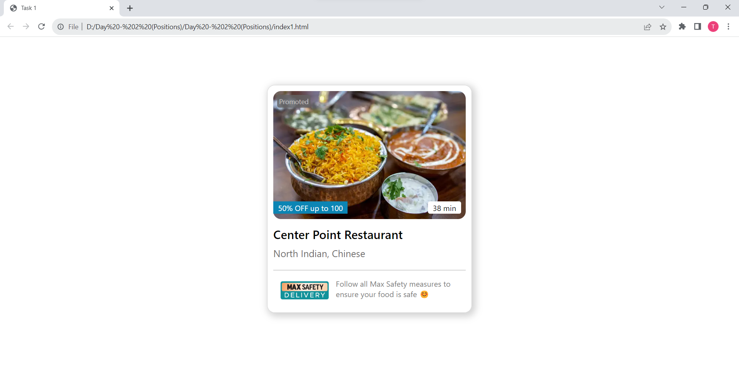

Tacsk 2: Explore

********** HTML CODE ********************

<!DOCTYPE html>

<html>

<head>

<meta charset="utf-8">

<meta name="viewport" content="width=device-width, initial-scale=1">

<title>Task 2</title>

<link rel="stylesheet" type="text/css" href="style2.css">

</head>

<body>

<div class="card">

<img src="https://source.unsplash.com/1600x1000/?sunrise" class="card-img"/>

<div class="body">

<h2>Explore the diversities in Bali</h2>

<p>Lorem ipsum dolor sit amet consectetur adipisicing elit. Fuga adipisci libero ipsum enim suscipit totam?</p>

<button class="explore-btn"> Explore Now </button>

</div>

</div>

</body>

</html>

***************** CSS ******************************

.card{

width: 700px;

margin: 100px auto;

padding: 10px;

font-family: system-ui, -apple-system, BlinkMacSystemFont, 'Segoe UI', Roboto, Oxygen, Ubuntu, Cantarell, 'Open Sans', 'Helvetica Neue', sans-serif;

border-radius: 10px;

position: relative;

text-align: center;

position: relative;

}

.card-img{

width: 100%;

border-radius: 10px;

}

.body{

position: absolute;

bottom: 70px;

color: white;

padding: 10px;

}

.explore-btn{

background-color: white;

border: none;

border-radius: 30px;

font-size: 16px;

margin-top: 10px;

padding: 12px 30px;

}

******************* OUTPUT *******************************

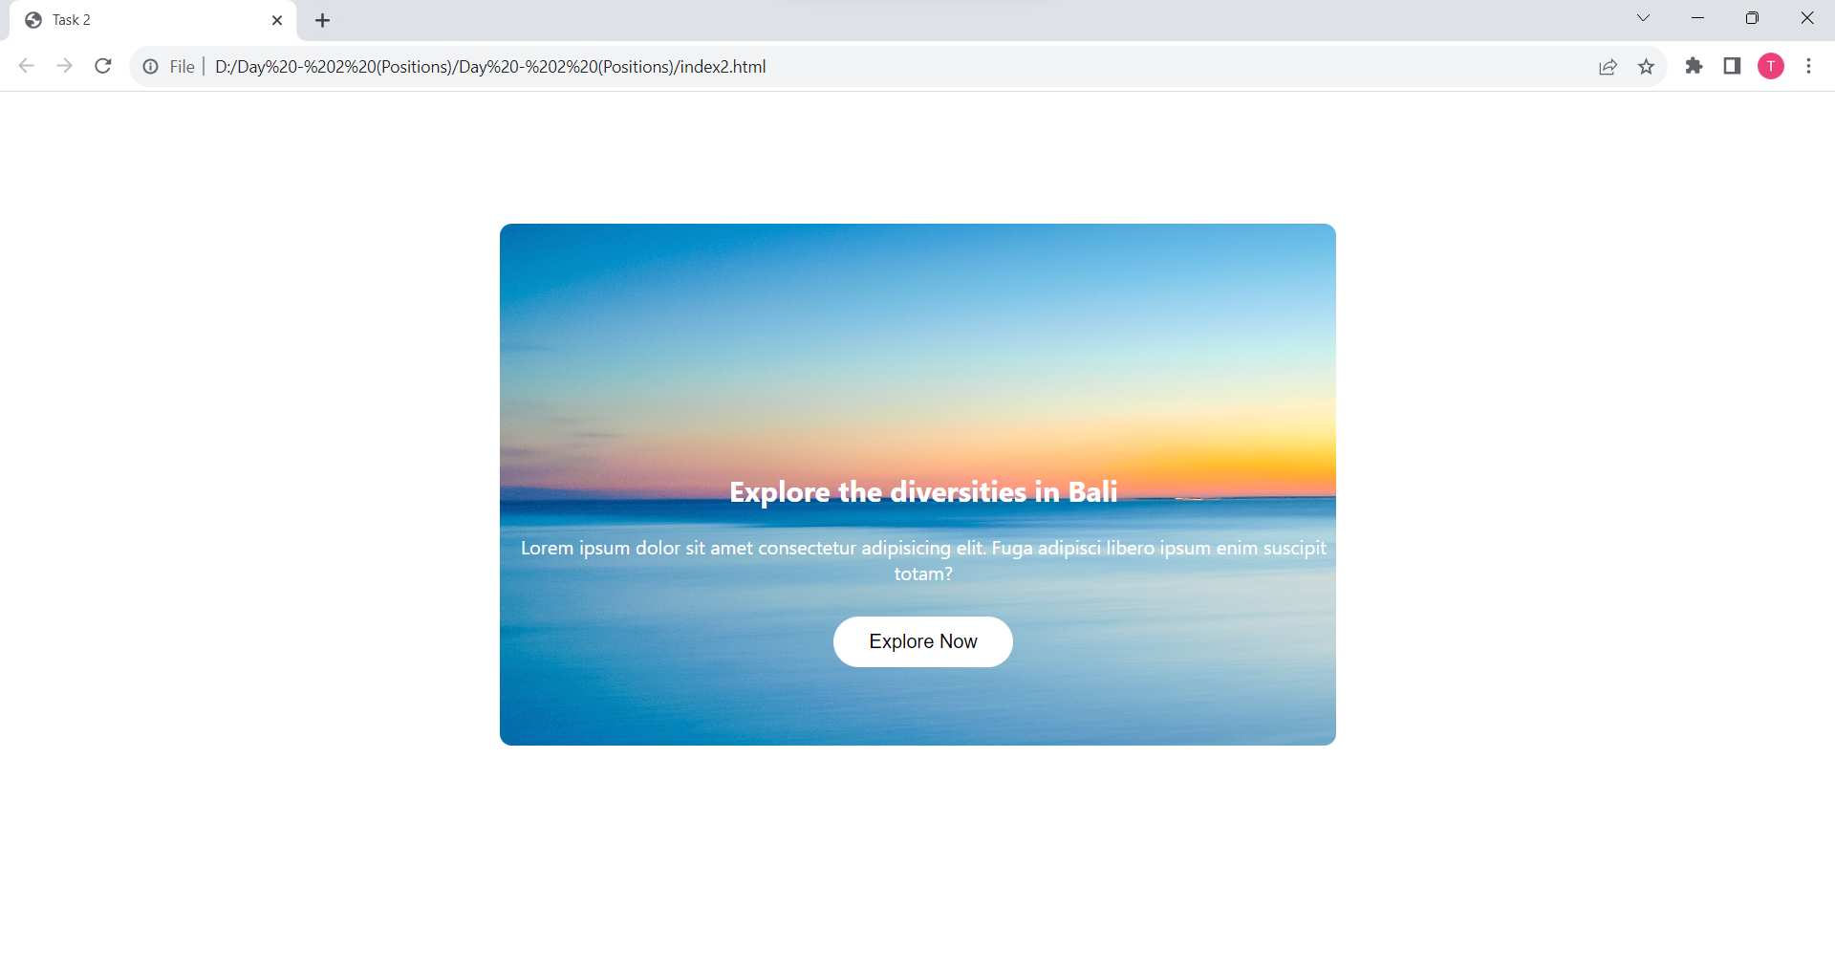

Tacsk 3:Zomato

********** HTML CODE ********************

<!DOCTYPE html>

<html>

<head>

<meta charset="utf-8">

<meta name="viewport" content="width=device-width, initial-scale=1">

<title>Task 3</title>

<link rel="stylesheet" href="https://cdnjs.cloudflare.com/ajax/libs/font-awesome/6.4.0/css/all.min.css" integrity="sha512-iecdLmaskl7CVkqkXNQ/ZH/XLlvWZOJyj7Yy7tcenmpD1ypASozpmT/E0iPtmFIB46ZmdtAc9eNBvH0H/ZpiBw==" crossorigin="anonymous" referrerpolicy="no-referrer" />

<link rel="stylesheet" type="text/css" href="style3.css">

</head>

<body>

<div class="card">

<img src="zomato.jpg" class="card-img"/>

<div class="body">

<i class="title">zomato</i>

<p class="slogan">Discover the best food & drink in Rajkot</p>

<div class="location-box">

<i class="fa-sharp fa-solid fa-location-dot small-img" style="color: red;"></i>

<p class="loc-name">Rajkot</p>

<i class="fa-solid fa-caret-down small-img"></i>

<i class="fa-light fa-pipe"></i>

<i class="fa-solid fa-magnifying-glass small-img border-class"></i>

<p class="loc-search ">Search for restaurant cuisine or a dish</p>

<div style="clear: both;"></div>

</div>

</div>

</div>

</body>

</html>

***************************** CSS **********************************************

.card{

width: 1400px;

margin: 100px auto;

padding: 10px;

font-family: system-ui, -apple-system, BlinkMacSystemFont, 'Segoe UI', Roboto, Oxygen, Ubuntu, Cantarell, 'Open Sans', 'Helvetica Neue', sans-serif;

border-radius: 10px;

position: relative;

text-align: center;

position: relative;

}

.card-img{

width: 100%;

border-radius: 10px;

}

.body{

position: absolute;

bottom: 120px;

left: 28%;

color: white;

}

.title{

font-size: 80px;

color: whitesmoke;

font-weight: 800;

font-family: sans-serif;

}

.slogan{

font-size: 30px;

}

.location-box{

width: 100%;

background-color: white;

color: gray;

text-align: center;

position: relative;

border: none;

border-radius: 10px;

}

.small-img{

float: left;

margin: 20px 10px;

}

.loc-name{

float: left;

margin-right: 100px;

}

.loc-search{

float: left;

margin-right: 200px;

}

.border-class{

border-left: 1px solid rgb(97, 97, 97);

border-radius: 0px;

padding-left: 15px;

}

********************** OUTPUT ***********************************************************************

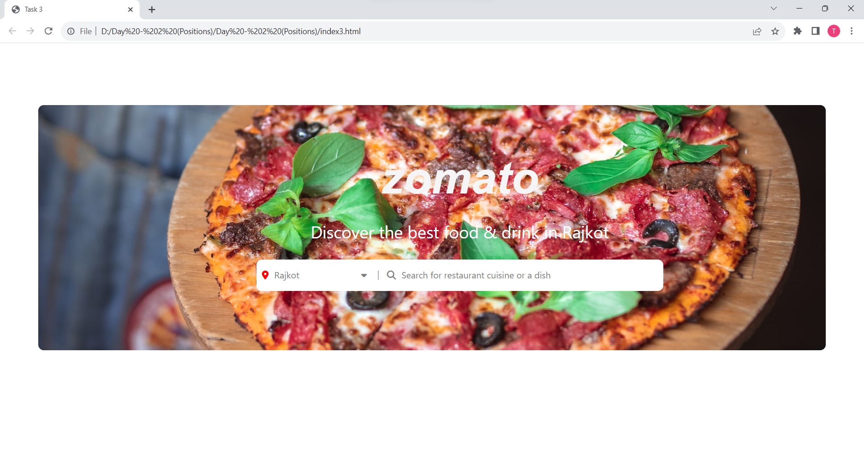

Tacsk 4: Profile

********** HTML CODE ********************

<!DOCTYPE html>

<html lang="en">

<head>

<meta charset="UTF-8">

<meta name="viewport" content="width=device-width, initial-scale=1.0">

<title>Task 4</title>

<link rel="stylesheet" type="text/css" href="style4.css">

</head>

<body>

<div class="profile-box">

<div class="image">

<img src="sunrise.jpg">

<div class="profile-pic">

<img src="myImg.jpg">

</div>

</div>

<h1>Kishan Dabhi</h1>

<h2>Artist & Manager at Vidhata Account</h2>

</div>

</body>

</html>

************************* CSS *************************************

body{

font-family: system-ui, -apple-system, BlinkMacSystemFont, 'Segoe UI', Roboto, Oxygen, Ubuntu, Cantarell, 'Open Sans', 'Helvetica Neue', sans-serif;

}

.profile-box{

width: 450px;

text-align: center;

margin: 100px auto;

border: 1px solid lightgray;

border-top-left-radius: 15px;

border-top-right-radius: 15px;

box-shadow:4px 4px 14px rgb(81, 81, 81);

}

.image{

position: relative;

width: 100%;

}

.image img{

width: 100%;

height: 150px;

border-top-left-radius: 15px;

border-top-right-radius: 15px;

}

.profile-pic{

position: absolute;

width: 100%;

bottom: -55px;

}

.profile-pic img{

width: 130px;

height: 130px;

border: 4px solid white;

border-radius: 50%;

}

.profile-box h1{

margin-top: 80px;

margin-bottom: 0px;

}

.profile-box h2{

font-weight: normal;

color: rgb(81, 81, 81);

margin-top: 12px;

margin-bottom: 40px;

}

**************** OUTPUT *************************************

